1. Understanding Asymptotic Notation
What is Big O Notation?
Big O Notation is used to describe the performance or efficiency of an algorithm as the input size increases.
It helps in:
- Measuring execution time growth.
- Comparing different algorithms.
- Predicting scalability for large datasets.
Common Big O Complexities
Complexity | Notation | Example
Constant | O(1) | Accessing an array element
Linear | O(n) | Linear Search
Logarithmic | O(log n) | Binary Search
Quadratic | O(n²) | Nested loops

Search Operation Scenarios
Best Case
The element is found immediately.
- Linear Search: O(1)
- Binary Search: O(1)
Average Case
The element is somewhere in the middle.
- Linear Search: O(n/2) ≈ O(n)
- Binary Search: O(log n)
Worst Case
The element is at the end or not present.
- Linear Search: O(n)
- Binary Search: O(log n)

2. Product Class
class Product {
int productId;
String productName;
String category;
Product(int productId, String productName, String category) {
this.productId = productId;
this.productName = productName;
this.category = category;
}
void display() {
System.out.println(productId + " - " + productName + " - " + category);
}
}

3. Implementation
Linear Search
public class EcommerceSearch {
public static Product linearSearch(Product[] products, int targetId) {
for (Product product : products) {
if (product.productId == targetId) {
return product;
}
}
return null;
}
public static void main(String[] args) {
Product[] products = {
new Product(101, "Laptop", "Electronics"),
new Product(102, "Mobile", "Electronics"),
new Product(103, "Shoes", "Fashion"),
new Product(104, "Watch", "Accessories")
};
Product result = linearSearch(products, 103);
if (result != null) {
System.out.println("Product Found:");
result.display();
} else {
System.out.println("Product Not Found");
}
}
}

Binary Search
Note: Products must be sorted by productId.
public class BinarySearchProduct {
public static Product binarySearch(Product[] products, int targetId) {
int left = 0;
int right = products.length - 1;
while (left <= right) {
int mid = left + (right - left) / 2;
if (products[mid].productId == targetId) {
return products[mid];
}
if (products[mid].productId < targetId) {
left = mid + 1;
} else {
right = mid - 1;
}
}
return null;
}
public static void main(String[] args) {
Product[] products = {
new Product(101, "Laptop", "Electronics"),
new Product(102, "Mobile", "Electronics"),
new Product(103, "Shoes", "Fashion"),
new Product(104, "Watch", "Accessories"),
new Product(105, "Headphones", "Electronics")
};
Product result = binarySearch(products, 104);
if (result != null) {
System.out.println("Product Found:");
result.display();
} else {
System.out.println("Product Not Found");
}
}
}
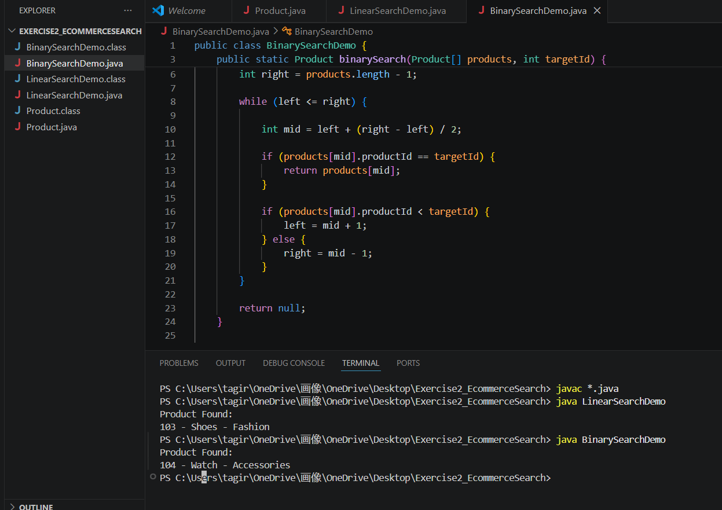
4. Analysis
Time Complexity Comparison
Algorithm | Best Case | Average Case | Worst Case
Linear Search | O(1) | O(n) | O(n)
Binary Search | O(1) | O(log n) | O(log n)
Binary Search is More Suitable
Reasons:
- Faster search performance.
- Handles large product catalogs efficiently.
- Requires fewer comparisons.
- Improves user experience with quicker search results.
When to Use Linear Search
- Small datasets.
- Unsorted data.
- Rare search operations.
When to Use Binary Search
- Large datasets.
- Frequently searched products.
- Data stored in sorted order.

